**PROJECT DEVELOPMENT PHASE**

**SPRINT-3**

|  |  |
| --- | --- |
| Date | 12 November 2022 |
| Team ID | PNT2022TMID00923 |
| Project Name | Signs with Smart Connectivity for Better Road Safety |

**SPRINT-3:**

1. **SPEED:**

* In sprint-3, we have implemented location sensor in MIT INVENTOR APP.
* This requires the user to turn on his location settings and with changes in his location with respect to time, speed of the user is determined and displayed in the user app screen.
* An image of normal speed limit is also added which indicates that it is safe to travel within the particular speed limit.
* This helps the user control his/her speed and thus reduces accidents and ensures safe drive.

**MIT APP INVENTOR:**

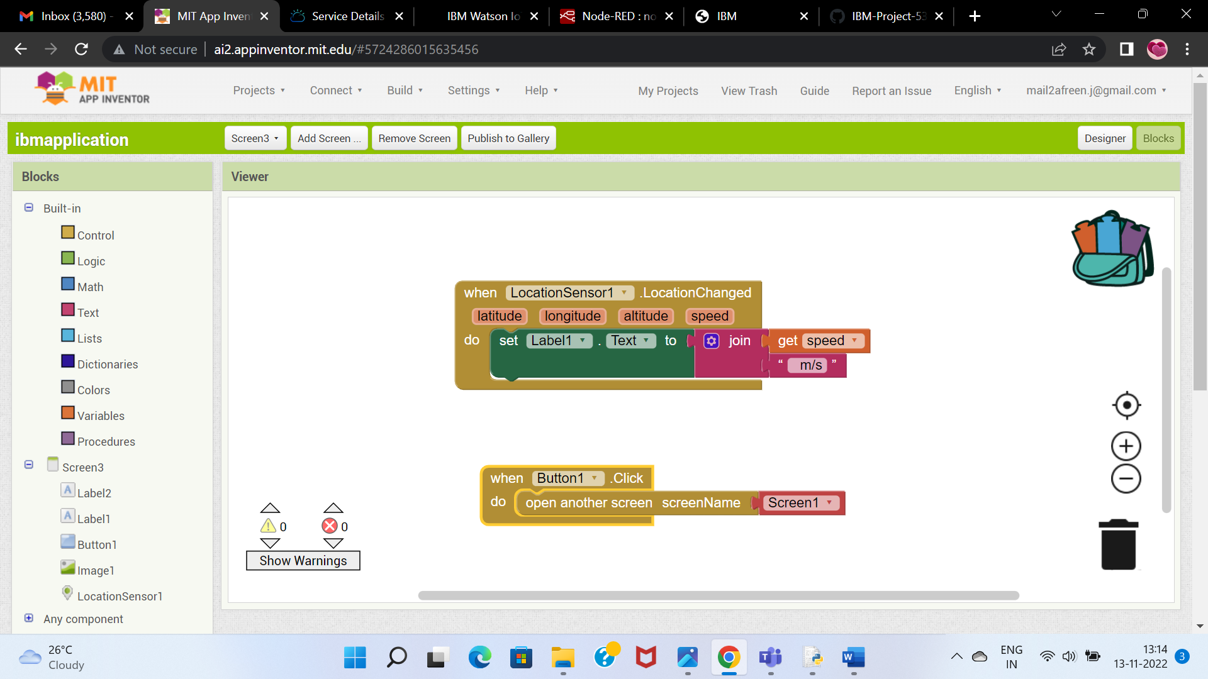

**USER APP SCREENSHOT:**

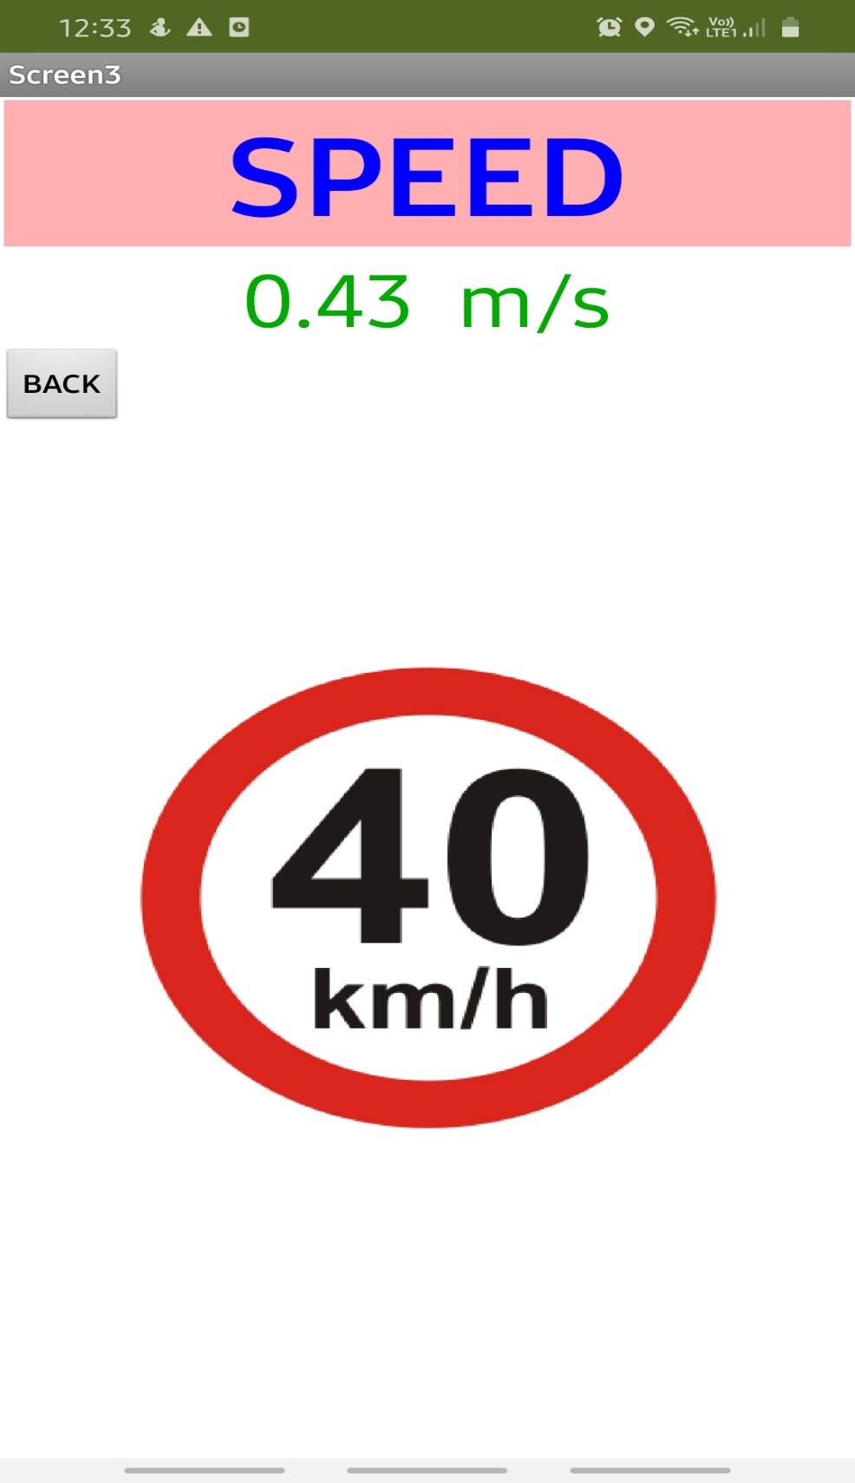

1. **NAVIGATION:**

* Here, we have implemented location sensor in MIT APP INVENTOR.
* By clicking the CURRENT LOCATION button in the app, the user can get his/her current location.
* User can drag and move the green marker to the start location and the red marker to the destination.
* By clicking the NAVIGATE button, a black path line connects the start and end point.
* Direction to reach the destination is also displayed below.
* This helps the users to know their own location and get to know about the best street route to reach the destination.

**MIT APP INVENTOR:**

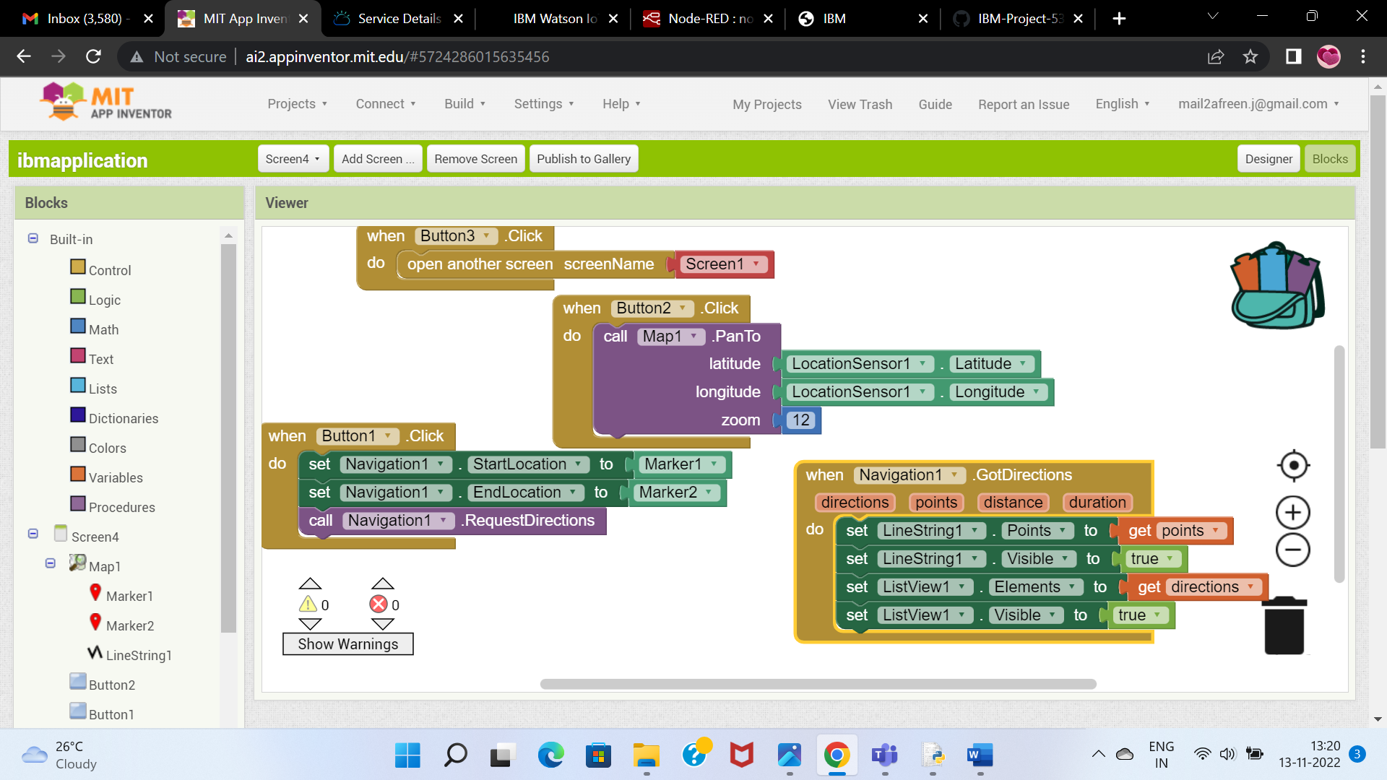

**USER APP SCREENSHOT:**

